For Your Saftey…Students and volunteers must wear long pants, hard soled shoes or boots. Excessively long pants or shirts are a saftey hazard and should be avoided. Long hair should be braided or placed in a pony tail.
Volunteers: Our volunteers are the life blood of EEC equine therapy. Without their hard work and dedication, our mission – to bring the benefits of equine therapy to individuals ina safe friendly enviroment – would be impossible.

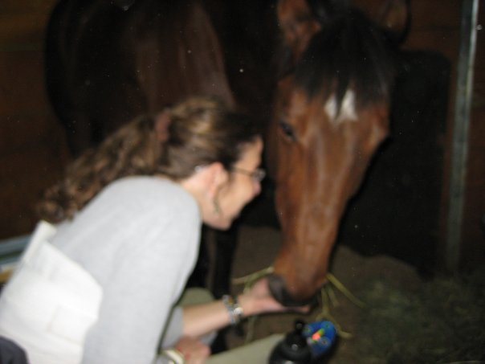
Who we are: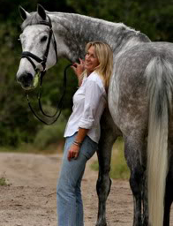
Karen Ball, our head instructor is a professional horsewoman who started her career in Germany. She has twenty years of experience giving instruction in equine facilitated learning. Karen is dedicated to improving the lives of individuals through horses.
About us:
Our programs are built on respect, communication, and trust. We hold the philosophy that horses change lives. They give our younger people confidence and self-esteem. They provide peace and tranquility to troubled souls. They give us hope.
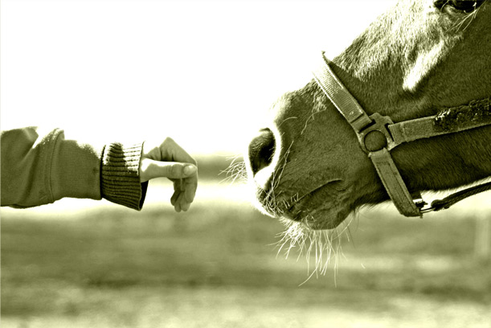
EUROPEAN EQUESTRIAN CONCEPTS
Riding & Horsemanship Program
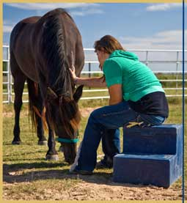
Proud Supporter of Horses Helping Kids
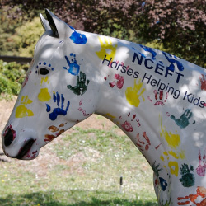
23401 Vía Pajaro Coto De Caza, CA 92679 (949) 375-2471 www.eeconepts.com
What is Equine Facilitated Learning? EFL is a therapy where adolescences learn about themselves, other people and interacting with the world. It's not about teaching riding or horse care and there’s no requirement of any previous experience with horses. "It's been clinically proven that just being in the vicinity of horses changes our brainwave patterns", says Karen. "They have a calming effect which helps stop people becoming fixated on past or negative events - giving them a really positive experience".
EFL has proven to be particularly useful for children with autism, attention deficit disorder (ADD) and bipolar disorders - all of whom may find it difficult to communicate, interact with other people and carry out instructions. The results are startling. Even those showing severe anti-social and aggressive behavior become calmer and more communicative.
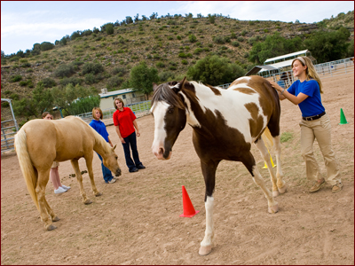

How it works "Horses react as a mirror to the person who's with him" says Karen. "He's a prey animal so he wants to feel safe and is always on the lookout for predators. A horse will become very fearful if he's with someone who's aggressive, noisy, disrespectful or too controlling. On the other hand, if the person makes requests rather than demands the horse will begin to cooperate. He is always looking for a leader." This is why horses are so good to use as therapy for children and adolescences. A child who is giving just a little insight into dealing with a horse in the right way can become the natural leader the horse is looking for. The horse in return feels safe and peaceful and willing cooperate with what the child asks him. Children, even those with emotional or mental disorder, can often manager a horse more easily and more quickly than adults. Children accept thing at face value and are more open to developing a dual relationship than trying to control. A horse is looking for simple and clear commands, and a child with the right encouragement and in the right situation, can carry these out very effectively. For children with mental and emotional disorder the positive benefits of getting a horse to carry out commands are profound. Children and adolescents with ADD will focus on the horse for long periods of while grooming or leading the horse when usually they can’t concentrate long enough on routine tasks. Autistic children who are withdrawn and living very much in their own world will begin to express themselves – often using new words or gestures they’ve never expressed before. Once adolescences realize what they can achieve their self-esteem increases in leaps and bounds. “Imagine what it must feel like to lead an animal through an obstacle course, stopping and starting when you want to, when you usually find it difficult to concentrate, communicate or stay in control?”

Horsemanship: Human society promotes anger, confrontation, aggression and competition at a very young age. Winning at any cost is usually rewarded. Positive recognition, social feedback and the emotional satisfaction we gain when we win condition people to focus and fixate on ‘winning’ and making something happen above all else. Horses are very uncomfortable with forceful tactics so this approach will not work with horses for very long. Our work with our students improves awareness and social skills, in having the desire to do well simply for the purpose of achieving a better relationship and harmony with the horse. They also must learn from the horses that it is OK to back down and start over with no hard feelings or animosity. WE model to our students feel for the horse, proper timing of requests, and the desire to set the horse (and ourselves!) up to succeed. Working in this manner helps us to achieve a shared body of trust and harmony with the horse.
- Improve self-confidence and self-discipline
- Build boundaries & personal space awareness
- Enhance self esteem
- Develop patience, trust and coordination
- Teach new recreational skills
- Leads to independence & courage
- Improve sensory integration

